**Student Directions/Information on Launchpad:**

LaunchPad is the book publisher’s website for the textbook we will be using for the course, Discovering Statistics. You need access to this website to complete the majority of homework assignments (Learning Curve, StatTutor topics, and Online Practice Quizzes). You can also use LaunchPad to read the book online as an e-book if you choose to. The hard copy textbook includes a formula card that may be a helpful reference during tests.

**Course: MBC638**

**Section/ Class#: M403 / 22348**

**Day and Time: Thursday, 9:00 PM EST**

**ID#: 4888512**

**LaunchPad URL:**

[http://www.macmillanhighered.com/launchpad/discostat3e/4888512](http://www.macmillanhighered.com/launchpad/discostat3e/4888512" \o "http://www.macmillanhighered.com/launchpad/discostat3e/4888512" \t "_blank)

**Directions to access LaunchPad:**

1. Click on the URL above to register for usage of LaunchPad

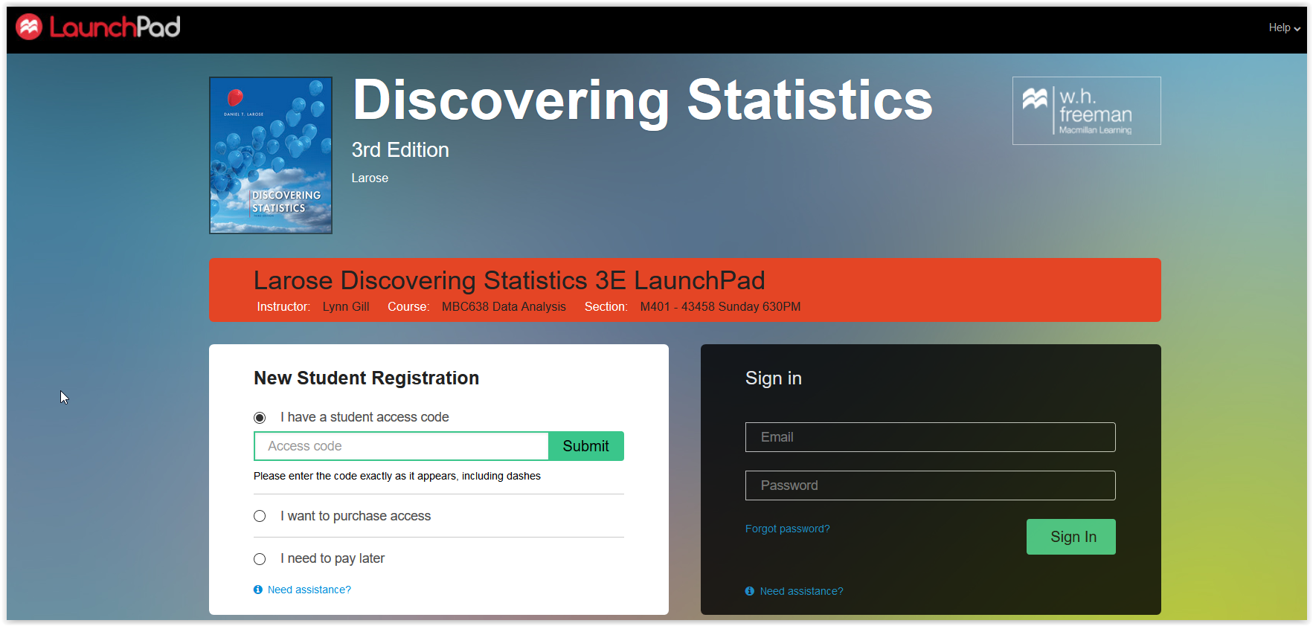

1. Enter **YOUR** Student Access Code (it came with the book or you purchased it separately) and click submit, in the box under New Student Registration
2. You will be prompted to enter your email address, in the event that you have previously used LaunchPad, then click Submit

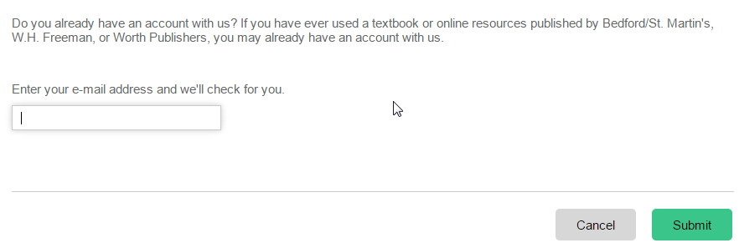

1. You will need to check the box that you have read the legal terms and that you agree to them

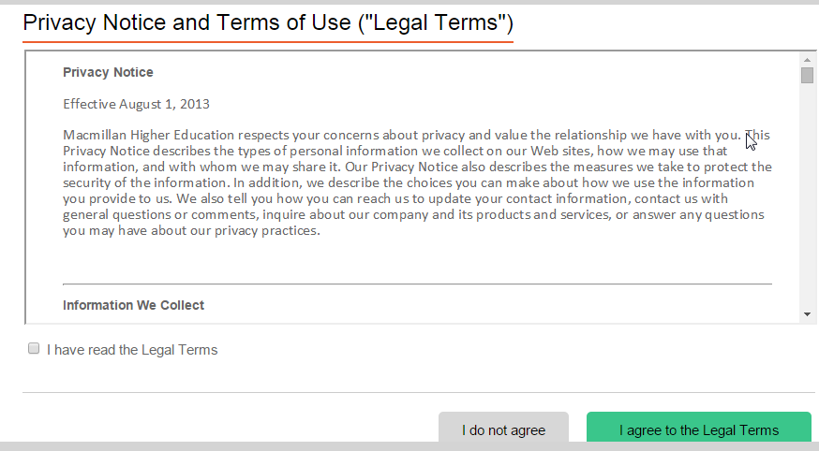

1. 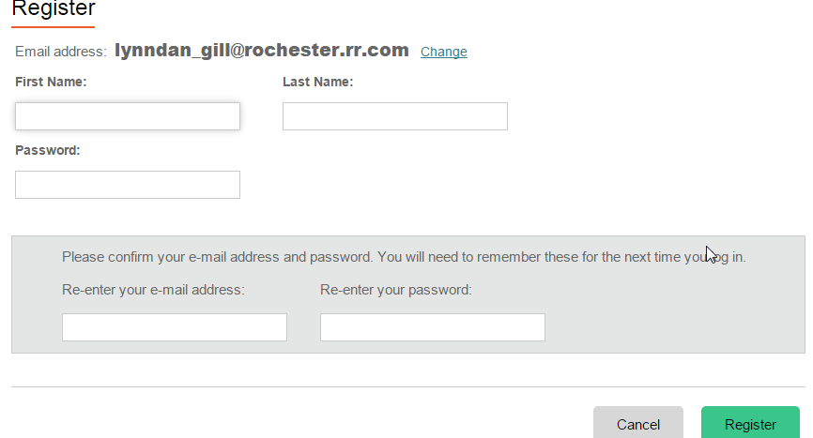Assuming you are new to the system you will enter your name, password, re-enter your email address and password, and the click Register to complete your registration.
2. You will then confirm you have selected the correct course by clicking, Join Course.

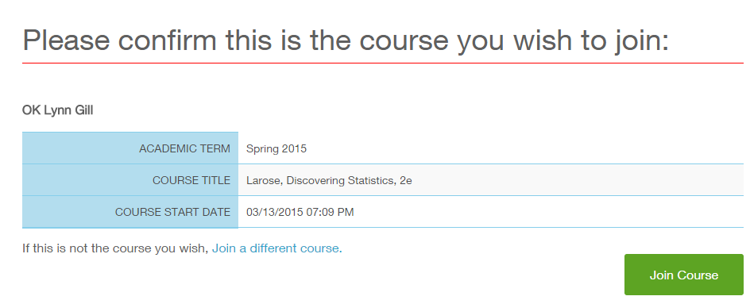

Example

1. You will then receive a congratulatory screen, where you can press continue to enter the online course which includes access to the e-book and the associated homework assignments. PLEASE NOTE THE URL (bookmark, add to favorites) for your course so you can easily access it later.

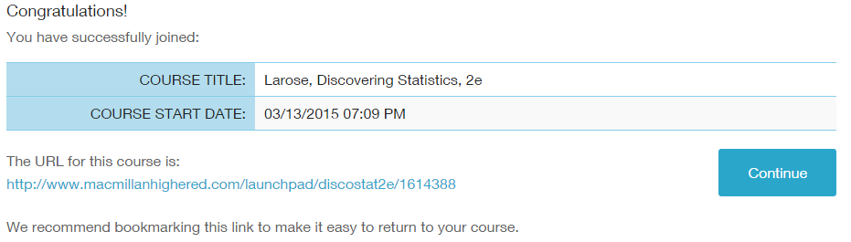

Example

1. You are now on the main page and click Enter Your Course to get access to the content.

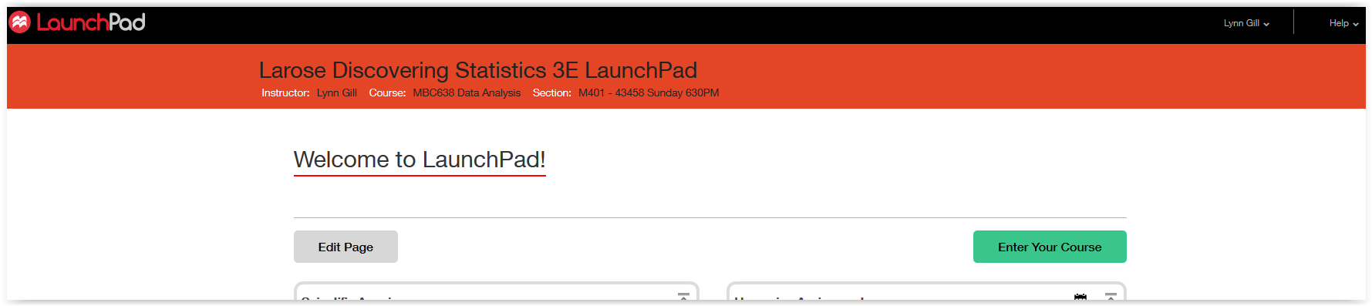

1. You will now see assignments listed at the top of the page with due dates, if you scroll down you can access the book content – or you may use the icons on the left side of the page.

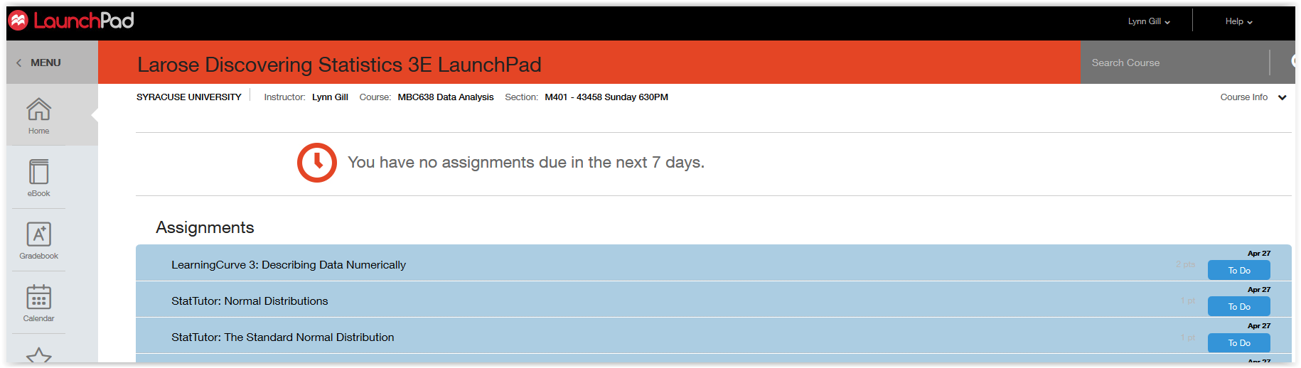

**Notes:**

* Google Chrome and Mozilla Firefox are the preferred browsers (not Internet Explorer)

**Other Resources for additional help:**

* Youtube video instructions: [https://www.youtube.com/watch?v=LzM3LWrzN6E](https://exchange.syr.edu/owa/redir.aspx?SURL=rZOgTlJRsd148QB9KdFjXYeGKq6mrbEDU_Hw36mzUVV1ILpsri_SCGgAdAB0AHAAcwA6AC8ALwB3AHcAdwAuAHkAbwB1AHQAdQBiAGUALgBjAG8AbQAvAHcAYQB0AGMAaAA_AHYAPQBMAHoATQAzAEwAVwByAHoATgA2AEUA&URL=https%3a%2f%2fwww.youtube.com%2fwatch%3fv%3dLzM3LWrzN6E)
* LaunchPad Support: 9 a.m. to 3 a.m. EST, 7 days a week at 1-800-936-6899, or under the help menu in the far right upper corner of the LaunchPad screen, you can access chat 24/7 or fill in the online email form